USER GUIDE TEMPLATE

Month of March 2025
Version 1.1

GLAMSPACE: YOUR BEAUTY HUB
USER GUIDE
Version 1.1
Prepared by: LAVENDA OKEY ALELA
KCA University
DBIT 506
23/06441
Date: 03/23/2025

DOCUMENT REVISION
DATE | VERSION NUMBER | DOCUMENT CHANGES
03/24/2025 | 0.1 | Initial draft
03/25/2025 | 1.0 | First draft
03/27/2025 | 1.1 | Final draft

Table of Contents
1. Introduction 5
1.1 Scope and Purpose 5
1.2 Process Overview 5
2. Getting Started 5
2.1 Registration 6
2.2 Login 6
3. Using Glamspace 6
3.1 Searching for Salons 6
3.2 Comparing Services and Prices 6
3.4 Leaving Reviews 7
4. Managing Your Profile 7
For Users: 7
For Salon Owners: 7
5. Troubleshooting 8
6. Appendices 8
Technical Specifications 8
Security Practices 8
7. Index 8

1. Introduction

1.1 Scope and Purpose
Glamspace: Your Beauty Hub is a web-based platform designed to help users locate nearby salons and barbershops, compare services and prices, and read reviews. This user guide provides step-by-step instructions for navigating the system, performing key tasks, and troubleshooting common issues.
Key Features:
- Location-based salon search
- Service and price comparison
- Booking
- Review and rating system
- User and salon management
Audience:
- End users (customers)
- Salon owners
- Administrators
Prerequisites:
- A stable internet connection
- Web browser (Chrome, Firefox, Edge)

1.2 Process Overview
- Register/Login: Create an account or log in to access the system.
- Search: Find salons/barbershops by location, services, or ratings.
- Compare: View and compare services and prices.
- Book appointment: book appointment according to your choice
- Review: Leave feedback for salons/barbershops.
- Manage Profile: Update user or salon information.

2. Getting Started

2.1 Registration
Steps:
- Click "Register" on the homepage.
- Fill in your details (name, email, and password).
- Click "Submit".
- Verify your email via the confirmation link sent to your inbox.
Note: Salon and barbershop owners must select "Register as Salon" and provide business details (name, location, services).

2.2 Login
Steps:
- Click "Login" on the homepage.
- Enter your email and password.
- Click "Submit".
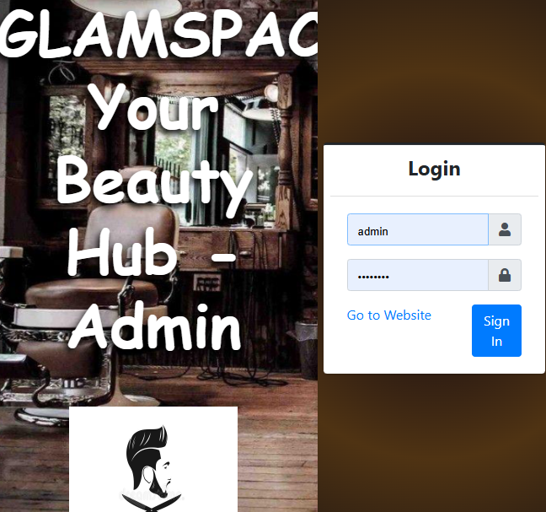
Forgot Password?
- Click "Reset Password" and follow the instructions.

3. Using Glamspace

3.1 Searching for Salons
Steps:
1. Type your city or any available service, e.g., haircut, on the homepage.
2. Let filters (value of the service, reviews) narrow your results.
3. Choose a particular salon to get more information about that salon (services, working time, phone number).

Interactive Map:
- Salons are pinned on the map. Click a pin to see details.

3.2 Comparing Services and Prices
Steps:
1. Search for the service you need, such as "manicure."
2. Browse the list of salons that offer this service.
3. Compare the costs and look at the ratings of each salon to help you decide.
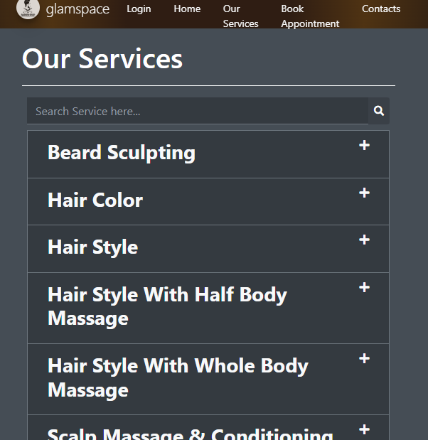
3.3 Booking services
Steps:
- Choose the service you want.
- Choose the location of your choice
- Book a suitable salon/barbershop.

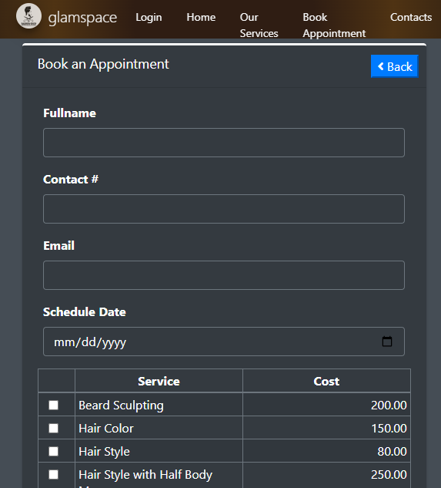

3.4 Leaving Reviews
Steps:
- Navigate to a salon’s details page.
- Click "Leave a Review".
- Rate the salon (1–5 stars) and write your feedback.
- Click "Submit".
Note: Reviews are subject to moderation for inappropriate content.

4. Managing Your Profile

For Users:
- Edit Profile: Update your name, email, or password.
- View History: Track past searches and reviews.

For Salon Owners:
- Update Salon Info: Modify services, prices, or operating hours.
- Respond to Reviews: Address customer feedback.

- Troubleshooting
Issues | Solution
Can’t log in | Reset password or contact support.
Search results are not loading. | Check your internet connection or try later.
Review not appearing | Ensure it meets guidelines.

Contact Support:
- Email: info@glamspace.com
- Phone: +254 768534814

6. Appendices

Technical Specifications
- Browser Compatibility: Chrome, Firefox, Edge
- Database: MS Access
- Frontend: HTML, CSS, JavaScript, Bootstrap

Security Practices
- Passwords are encrypted.
- User data is stored securely.

7. Index
- Registration
- Salon Search
- Booking appointments
- Reviews
- Troubleshooting

DISCLAIMER
This document is for informational purposes only. Glamspace reserves the right to update features or policies without prior notice.

